**Restaurant Management System**

**Introduction**

The Restaurant Management System (RMS) is a comprehensive software solution designed to streamline and enhance the operations of a restaurant. The system incorporates modules to manage customers, employees, orders, menus, order items, restaurant settings, and billing processes.

Each module plays a vital role in creating a seamless and organized environment for restaurant owners and staff.

**Architecture**



**REST Client**

Spring Data JPA

**Restaurant Management System**

Spring MVC

**Restaurant Management System**

MySQL

Database

**MVC Architecture**

Customer

Repository

Customer

Service

Customer

Controller

MySQL

Browser

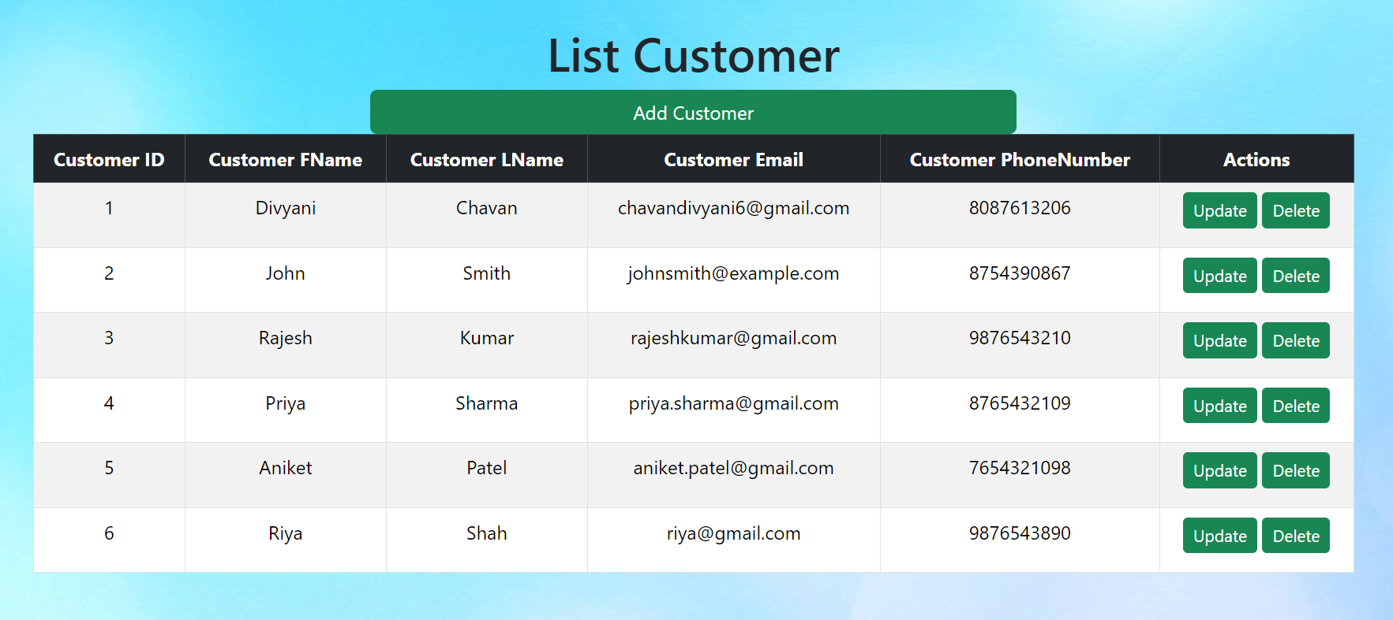

**API Table**

|  |  |  |  |  |
| --- | --- | --- | --- | --- |
| Sr No | API Name | HTTP Method | Path | Description |
| 1 | getAllCustomer() | GET | /GetCust | Get All Customer Data |
| 2 | CreateCustomer | GET | /Cust/New | To Access Insert Form |
| 3 | saveCustomer | POST | /Cust/save | Save record into database |
| 4 | getCustomerById() | GET | /Cust/edit/{id} | Get data by id |
| 5 | getAllCustomer Data | POST | /Cust/update/{id} | Update data |
| 6 | deleteCustomerById() | GET | /Cust/delete/{id} | Delete Data by id |

**Restaurant Management System**

1. Creation of spring project (restaurantmanagementsystem)done
2. Packages creation done

**package** com.restaurant.entity;

**package** com.restaurant.controller;

**package** com.restaurant.repository;

**package** com.restaurant.exception;

**package** com.restaurant.service;

**package** com.restaurant.service.impl;

1. Inside package classes and interface creation done

**package** com.restaurant.entity;

**(Classes)**

1. **Customer.java**
2. **Employee.java**
3. **Order.java**
4. **Menu.java**
5. **OrderItem.java**
6. **Restaurant.java**

**package** com.restaurant.controller;

**(Classes)**

1. **CustomerController.java**

**package** com.restaurant.repository;

**(Interfaces)**

1. **CustomerRepository.java**
2. **EmployeeRepository.java**
3. **OrderRepository.java**
4. **MenuRepository.java**
5. **OrderItemRepository.java**
6. **RestaurantRepository.java**